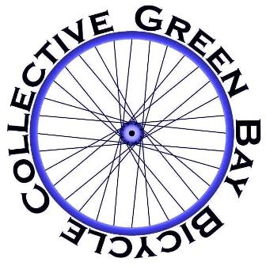

Date_____________
Amount__________

Member sign up 2016
Name___________________________________________
Email___________________________________________
Address_________________________________________________________________________________________
Annual membership is $10. Make check or money orders out to Green Bay Bicycle Collective. Send to 249 Kenney St., Green Bay, WI 54301
Member cards are sent out in 5-10 days. Personal address is used only to send member cards. Email is used to send newsletters and updates. Personal information is not shared with anyone.

